**Business Intelligence**

BIA-5401-0LA

Group Case Study 2

**Retail Sales Analytics**

**Group:** 6

**Team Members:**

1. Alexandra Gladkova
2. Bishwajit Dutta
3. Christina Saju
4. Hao Lun Rong
5. Kushwanth Sai Kolli
6. Ladan Asempour

**Submitted to:** Professor Haytham Qushtom

**Submission Date**: 3/26/2025

**1. Create MySQL Database**

**SQL Code Screenshot: Creating Database & Table**

**Result**

**Load data from CSV files into MySQL database**

To import data from CSV files into our tables, we followed a series of steps.

First, we right clicked on the respective table in the navigation panel, chose the "Table Data Import Wizard," browsed and selected the CSV file, selected the table where the data should be loaded, checked the column mappings to ensure accuracy, and finally, proceeded with the import process to successfully add the data to the table.

**Load data in respective tables:**

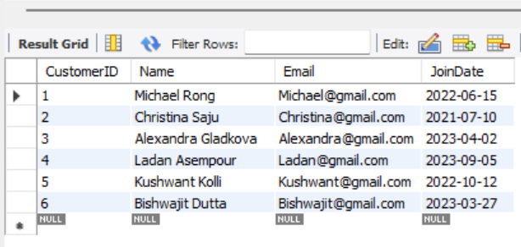**Customer Table:**

****Product Table:**

*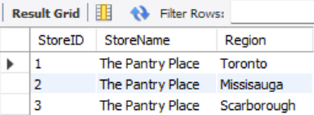***Store Table:**

****Part of the Date Table:**

****Part of the Order Table:**

**Part of the OrderItems Table:**

**2. Dimensional Modeling**

Dimensional model

The dimensional model is designed using a star schema, which includes fact and dimension tables to help analyze business data efficiently.

The fact tables are *Fact_Order* and *Fact_OrderItems*. The Fact_Order table captures transactional details such as OrderID, CustomerID, StoreID, OrderDate, TotalAmount, and PaymentMethod, while *Fact_OrderItems* stores details about each product in an order, including OrderID, ProductID, StoreID, and Quantity. These fact tables store measurable business data that can be analyzed using dimension tables.

Primary keys (PK) and foreign keys (FK) play important roles in the fact tables by maintaining data integrity and enabling efficient joins with dimension tables. In the *Fact_Order* table, OrderID is the primary key (PK), which uniquely identifies each transaction. The table also contains foreign keys (FK) such as CustomerID, StoreID, and OrderDate, which link to Dim_Customer, Dim_Store, and Dim_Date, respectively, allowing for detailed analysis of sales by customer, location, and time.

In the *Fact_OrderItems* table, the PK is a composite key consisting of OrderID and ProductID, ensuring that each product within an order is uniquely identified. The table also includes FKs for OrderID, ProductID, and StoreID, which connect to *Fact_Order*, Dim_Product, and Dim_Store, respectively. These relationships help in analyzing sales performance at the product and store level.

The dimension tables provide descriptive details to support business queries. Dim_Product contains product-related information such as ProductID, ProductName, Category, and UnitPrice. Dim_Customer stores customer details like CustomerID, Name, Email, and JoinDate. Dim_Store helps track store locations with StoreID, StoreName, and Region. Dim_Date allows for analyzing sales trends over time using OrderDate.

The star schema effectively supports key business queries. For total and average sales by day, month, and year, we can utilize *Fact_Order* and Dim_Date to group and calculate sales over time. Sales trends by product category and region can be analyzed by joining *Fact_OrderItems* with Dim_Product and Dim_Store to break down revenue by category and location. Customer retention can be measured by counting orders per customer in *Fact_Order* and filtering those who meet a minimum order threshold. To analyze payment method distribution in the top revenue-generating region, we can identify the highest-earning region from *Fact_Order* and Dim_Store, then examine the payment methods used there.

**3. Business Analysis Using Stored Procedures**

**Total & average sales by day, month, and year**

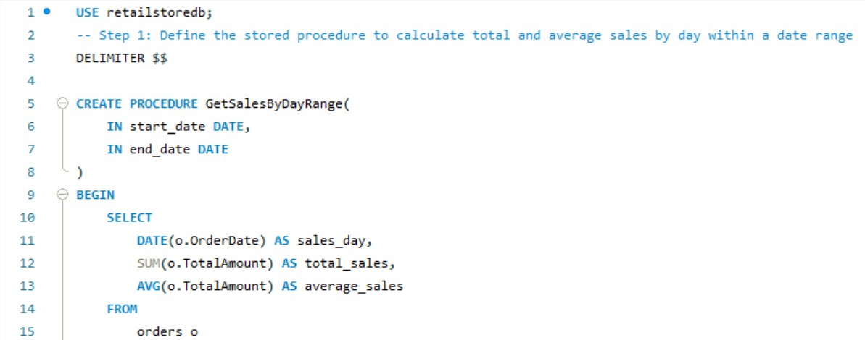

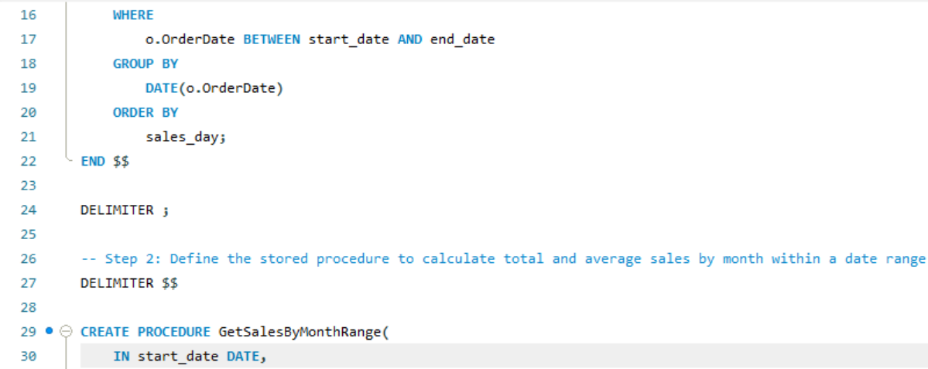

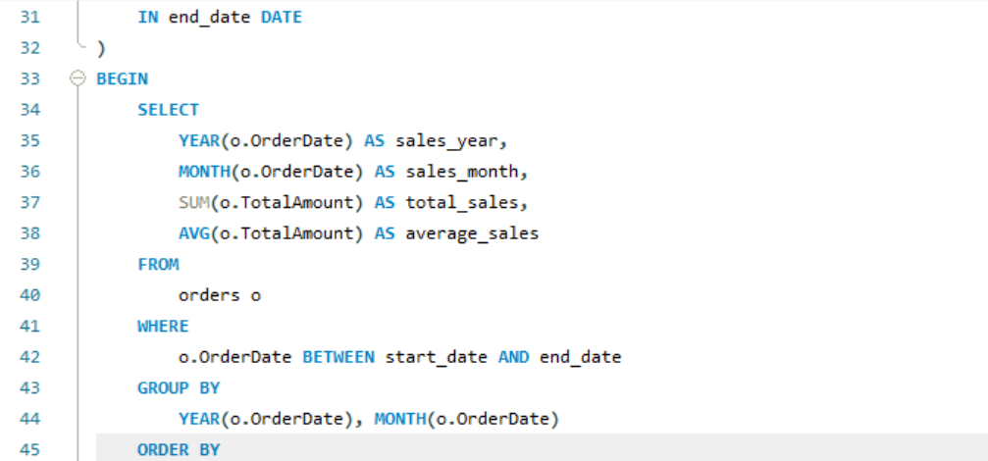

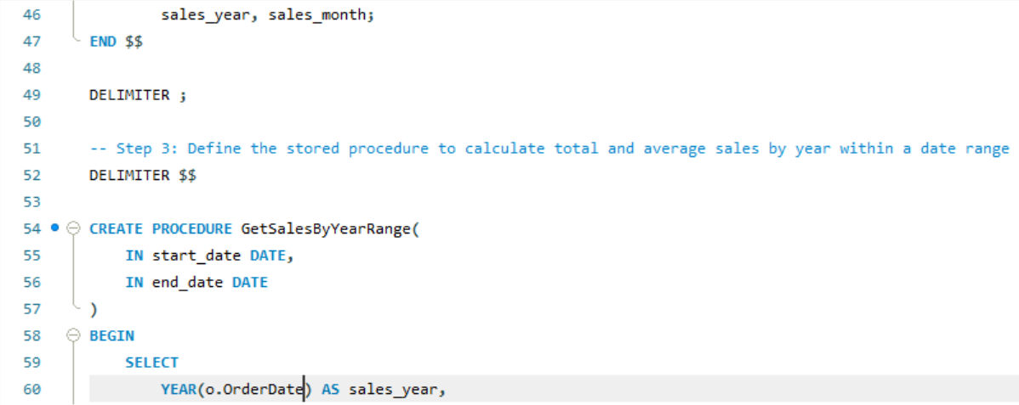

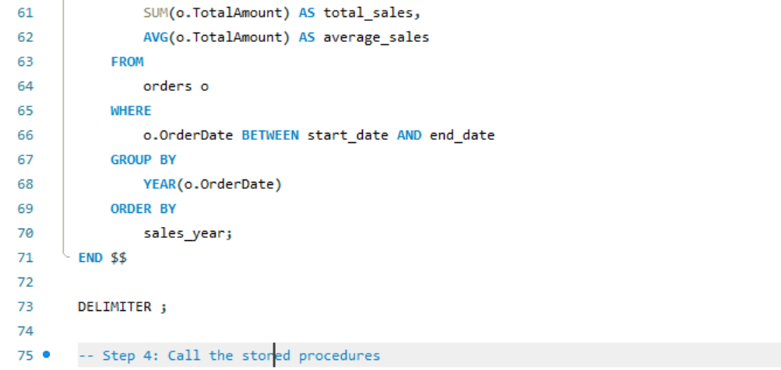

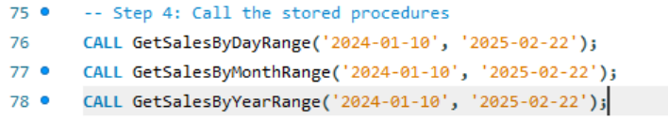

**Total Sales and Average Sales by Day**

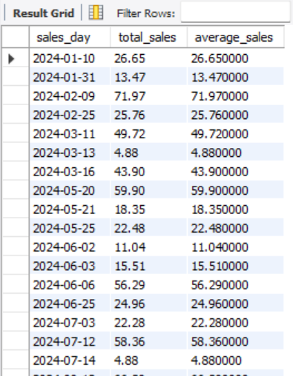

The GetSalesByDayRange procedure revealed fluctuations in daily sales. For example, the highest daily sales were $71.97 (with an average of $71.97) on '2024-02-09', while the lowest were $4.88 (with an average of $4.88) on '2024-03-13' and '2024-07-14'.

**Total Sales and Average Sales by Month**

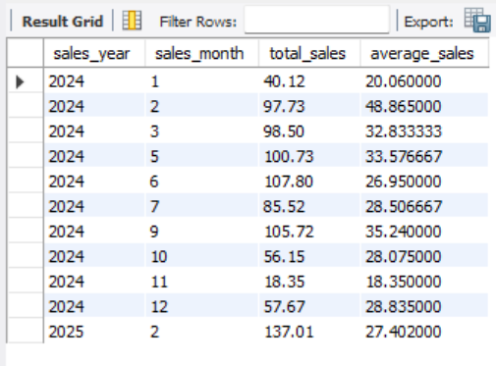

The GetSalesByMonthRange procedure showed variations in monthly sales. February 2024 had total sales of $97.73 with an average of $48.865, and June 2024 had $107.80 (with an average of $26.95), while November 2024 had a low of $18.35 with an average of $18.35.

**Total Sales and Average Sales by Year**

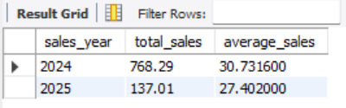

The GetSalesByYearRange procedure highlighted a substantial drop in sales from 2024 to 2025. Total sales for 2024 were $768.29, with an average of $30.73, while 2025 showed total sales of $137.01, with an average of $27.40.

**Sales trends by product category and region**

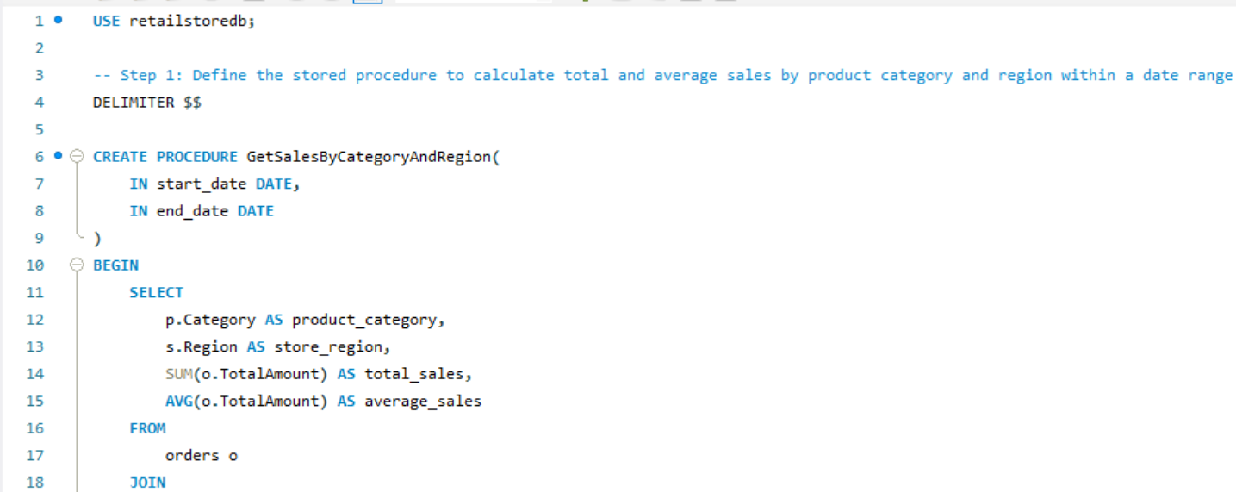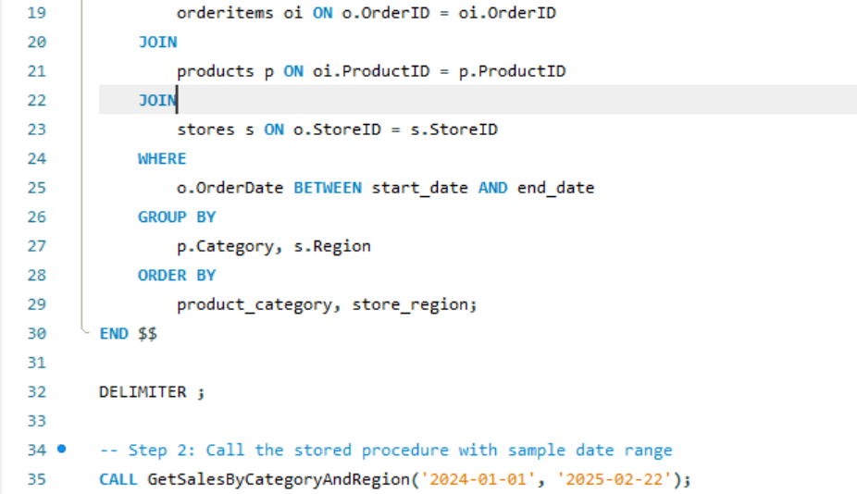

**Result**

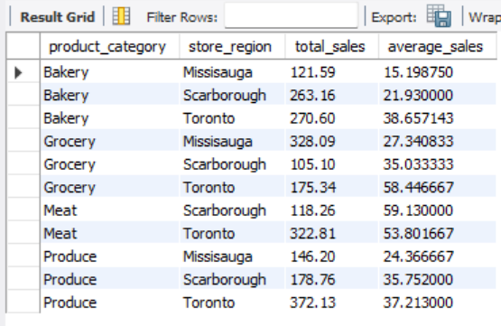

To analyze sales trends by product category and region we created a stored procedure that calculates total and average sales for each category in each region within a date range.

* **Bakery:**
  + Toronto has the highest total bakery sales at $270.60, with an average of $38.66.
  + Mississauga has the lowest bakery sales at $121.59, with an average of $15.20.
* **Grocery:**
  + Mississauga has the highest total grocery sales at $328.09, but Toronto has the highest average grocery sales at $58.45.
  + Scarborough has the lowest total grocery sales at $105.10.
* **Meat:**
  + Toronto has the highest meat sales at $322.81, with an average of $53.80.
  + Scarborough meat sales are $118.26 with the highest average of $59.13.
* **Produce:**
  + Toronto has the highest produce sales at $372.13, with an average of $37.21.
  + Mississauga has the lowest produce sales at $146.20.

**Customer retention based on order frequency**

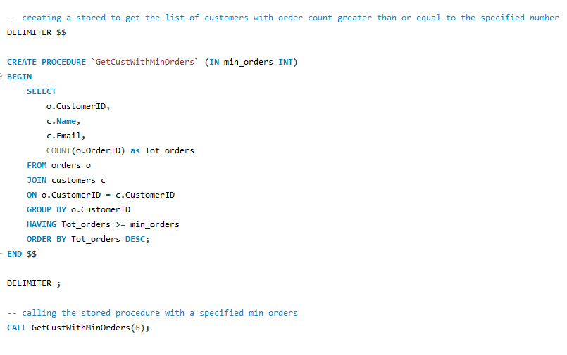**Result**



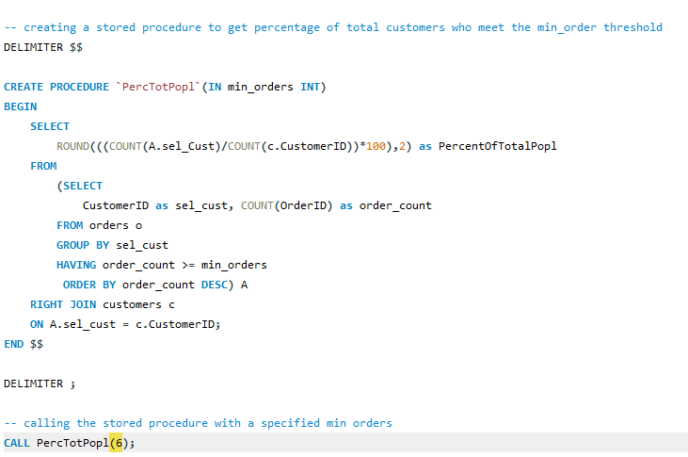

**Result**



Only 16.67 % of customers met the minimum order requirement, which means that the majority of customers have not returned to make another purchase.

**Payment method distribution in the top revenue-generating region**

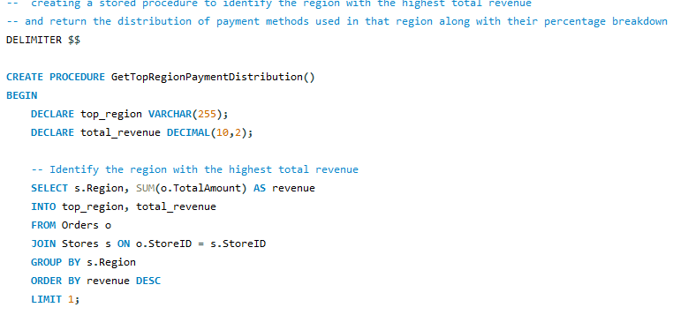

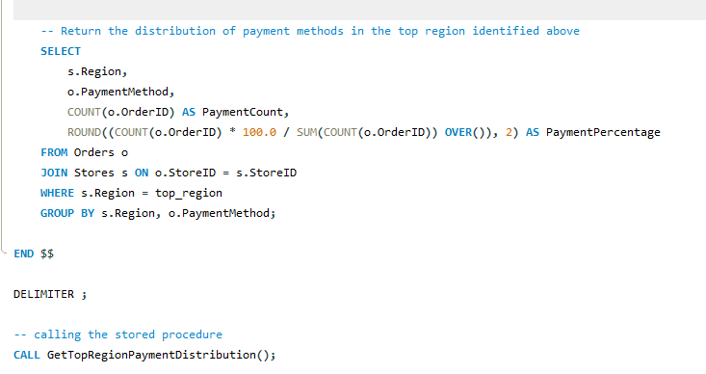

**Result**

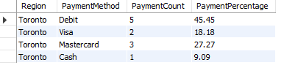

Toronto is the top-performing region, and its customers present a diverse distribution of payment methods with debit payments being the most popular at 45.45 %, followed by credit cards such as Visa and Mastercard, and cash as the least frequent method of payment, displaying a strong customer preference of cashless payment options.

**4. Conclusions and key insights**

This analysis has provided us some insight into the grocery store chain’s operations and statistics to derive conclusions and recommendations by area of improvement.

One of the key factors is seasonal sales fluctuations which suggest opportunities for price and promotion optimization during low-sales months. Seasonal discounts and promotions as well as supplying seasonal produce and holiday-themed grocery items can help us achieve the sales goal during lower-sales months.

Product performance varies by region, which indicates that we should focus our effort on localized marketing strategies to drive engagement based on region. By studying regional demand trends, we can offer customized product selection to specific regions to drive our sales.

Given that most customers did not meet the minimum order requirement the churn related concerns are high and pose a risk to our overall sales. By implementing loyalty programs and personalized discounts we can improve customer retention rates, gain repeat customers and support the business’s reputation.

Lastly, with credit and debit cards being the most common method of payment, we can diversify income streams by offering perks associated with certain payment methods, such as coupons or collectible cards that can later be exchanged for discounts with every cash purchase or even partner with a credit provider and offer our store’s brand credit card associated with personalized discounts, points and seasonal benefits.

By addressing these key insights, we can establish a more sustainable competitive advantage in the grocery market.